**Div summary**

**Structuring a page with div**

In most web pages, different contents are grouped in different <div> sections.   
Div stands for **div-ision** because it’s a way of dividing your page’s content into different sections.

**CSS properties**

Here are common CSS properties on <div>.

**Width, height, padding and margin**

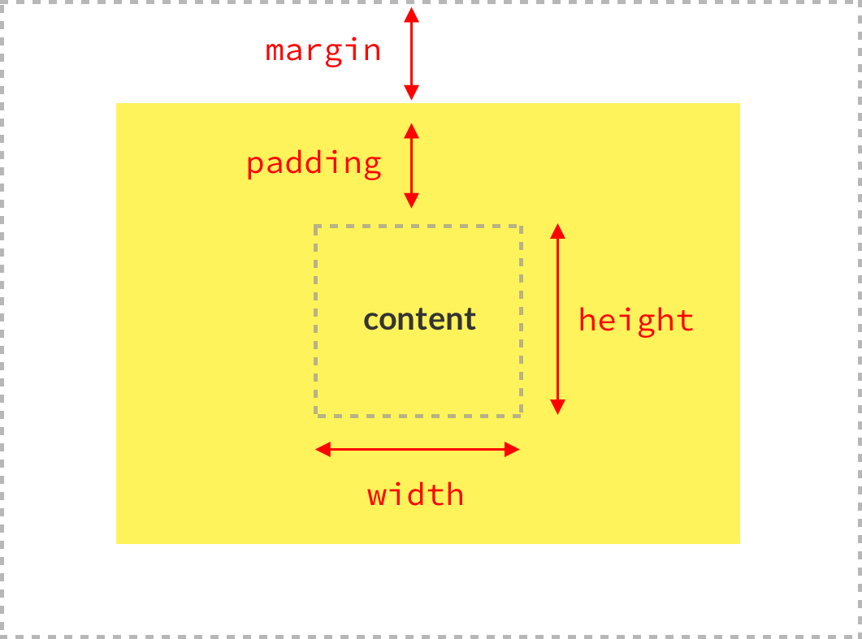

You can either define the same margin & padding in all directions (top / bottom / left / right):

margin**:** 80px**;** */* will put 80px of margin everywhere */*

padding**:** 40px**;** */* will put 40px of padding everywhere */*

Or you can also define different top / bottom and left / right values:

margin**:** 80px 0px**;** */* 80px of top/bottom margin and 0px of left/right margin*/*

padding**:** 0px 24px**;** */* 0px of top/bottom padding and 24px of left/right padding*/*

Finally, you can be even more specific and define all directions one by one:

margin**:** 80px 0px 40px 16px**;** */* top: 80px, right: 0px, bottom: 40px, left: 16px*/*

In the last case, the order is just the order **clockwise 🕑 starting at the top**.

**Border**  
You can define the same border everywhere:

border**:** 1px solid red**;**

Or be more specific:

border-top**:** 1px solid red**;**

border-right**:** 2px dotted black**;**

border-bottom**:** 1px dashed green**;**

border-left**:** 2px dotted black**;**

We would advise you to try and use a very light rgba color and a small width of 1px for an elegant border. For instance:

border-top**:** 1px solid rgba**(**0**,** 0**,** 0**,** 0**.1);** */* elegant border: thin and subtle */*

**Border radius**  
You can soften the corners of a div with a border radius:

border-radius**:** 4px**;**

Again, use small values like 4 of 5 pixels.

Also, if you have a square picture or div and you want to make a perfect circle, you can use a 50% border radius like so:

**.perfect-circle** {

**width**: 100px;

**height**: 100px;

**border-radius**: 50%;

}

**Box shadow**  
This is how you put a shadow on a div

box-shadow**:** 2px 2px 3px red**;** */* horizontal-shift vertical-shift blur color */*

**Classic design technique**  
Here are some CSS rules to obtain a nice **nice and clean** div ✨

background**:** white**;** */* White background */*

padding**:** 30px**;** */* Internal space */*

border-radius**:** 4px**;** */* Small radius */*

box-shadow**:** 0 10px 30px rgba**(**0**,**0**,**0**,.1);** */* Light shadow */*

This is the result of these CSS rules ☝️. How cool is that 😎?

**Centering technique**  
This is a classic technique to center a <div>:

width**:** 300px**;** */* Fix the width first*/*

margin**:** 0px auto**;** */* Let CSS compute the same left & right margins automatically*/*

This is a div of 300px centered using automatic margin on the left and on the right.

Of course, you can put a different value than 0px for the top / bottom margin if you want.